Contents

- Introduction
- Principles of Asset Management
- Five Asset Management Principles
- The processes encompassed in Asset Management Encompasses
- Classification of Assets
- Distinction between Current and Capital Expenditure
- Depreciation
- Disclosure requirements
- Asset Register
- Accessing HardCat
- HardCat User Administration
- HardCat Security
- Why can’t I log in?
- HardCat Core Module Functionality
- Type structures
- Reporting for Managers
- Budgeting
- Stores
- Benefits of using HardCat
- Definitions

- Introduction
In order to meet the statutory requirement (PFMA Section 38(1) d), a framework was developed to promote the effective management of assets. The framework is primarily intended to assist financial managers to interpret and implement sound asset management principles. The principles of asset management give rise to a business problem for which we need a tool (HardCat) to resolve.

- Principles of Asset Management
Asset Management is the process of guiding the acquisition, use, safeguarding and disposal of assets to make the most of their service delivery potential and manage the related risks and costs over their entire life. Therefore we need a proper tool (HardCat) to achieve this, and the tool will assist in the following five asset management principles.

- Five Asset Management Principles
- Service delivery needs are to guide asset practices and decisions: Departments are to undertake asset management activities within a strategic framework that is driven by programme and service delivery needs.
- Asset planning and management are to be integrated with strategic business plans, budgetary and reporting processes: Planning, budgeting for, and reporting on assets are to be integrated with broader planning processes, both within departments and between central and other departments. HardCat will assist in terms of asset planning after identifying what type of assets are going to be needed in delivering services to the public. HardCat will act as a record showing assets in use and idle assets (asset register), Alternatives have to be taken into consideration as to whether are there any alternative rather than buying a new asset.
- Asset Management decisions are to be based on evaluations of alternatives that take into account full life cycle costs, benefits and risks of assets: Capital expenditure decisions are to be based on rigorous and documented economic appraisals of options that include financial as well as non-financial parameters.
- Ownership, control, accountability and reporting requirements for assets are to be established, clearly communicated and implemented: Ownership and control of all assets are to be fully defined. Accountability and reporting requirements for both ownership and control are to be determined and clearly communicated.
- Asset management activities are to be undertaken within an integrated Government asset management policy framework: Department asset management is to be based on best practice in government and industry and on government policy.

- The processes encompassed in Asset Management Encompasses

This section gives more details regarding the above five principles.
- Planning
Planning is the essential tool for achieving service delivery objectives by means of assets. Department’s asset management plans, decisions and activities must be fully integrated with the Government’s planning processes, including department, strategic business plans. Risk assessment and allocation must start at the planning stage. Departments must continue to verify service needs throughout the planning process. It is considered important that when estimating the useful life of an asset, its planned maintenance should also be considered during the planning stage.

- Needs analysis
This is the starting point for asset management. Departments must thoroughly examine the need for service and infrastructure provision and consider the full range of options for responding to it.

- Economic Appraisal
This is a systematic weighing up of the costs and benefits of the various asset based and non-asset based solutions identified. Value management is one technique that assists in this process.

- Budgeting Planning of funding for the asset
Assets require the commitment of funding over their entire lives which includes capital expenditure for their purchase or construction and recurrent expenditure for their ongoing maintenance and operation. The disposal value at the end of their service life must also be considered. Expenditure requirements must be covered by identified sources of funding.

- Pricing the use of assets
Pricing should be based on the true cost of creating, operating, maintaining and eventually disposing of the asset, and should reflect the department’s service and market conditions. The true cost includes a rate of return, the operating and maintenance expenditure and a depreciation allowance. Pricing may also be used as a way of managing demand.

- Acquisition and disposal
Decisions regarding acquisition/disposal require thorough examination and economic appraisal. The options for acquiring assets include creating, purchasing or leasing. The options for disposal include alternative use, rental, sale, or sale and lease-back, and should be considered as part of the acquisition strategy.

- Recording, valuation and reporting
Departments are accountable for the physical and financial performance of the assets they control, operate and maintain. Information about the performance and condition of an asset provided buy accurate recording, valuation and reporting procedures is critical to decisions to modify, refurbish, find an alternative use for, or dispose of an asset. The maintenance of an asset register which comprises an accurate record and valuation of assets will support effective decision-making about asset utilization.

- Management in use
Protecting service delivery potential is a priority when making decisions about asset use and maintenance. How long an asset is useful depends on how effectively it is maintained and safeguarded for its purpose. Post-acquisition reviews and evaluations must be carried out periodically to verify that required outcomes are being achieved.

- Classification of Assets
Assets may be current or non-current. Current Assets may have an expected shorter life due either to an inherent feature (perishable goods for example) or because they will be converted into another asset or consumed within the department within a short timeframe.
In contrast, Non-current assets have an extended, useful life greater than one year and it is usually expected that these assets would be used during more than one reporting period.
Tangible (Physical Assets)
Intangible

- Land Financial Assets
- Infrastructure Assets - Cash and Cash equivalents
- Heritage Assets - Marketable Securities and Deposits
- “Owner occupied” Property - Receivables
- Investment Property - Shares in subsidiaries, associated
- Machinery, Plant and Equipment companies and joint ventures
- Transport assets - Long term securities and bonds
- Specialist military assets - Other financial assets
- Mineral rights and similar - Accrued revenue
Non-regenerative resources - Inventories
- Biological Assets - Agricultural Produce

- Distinction between Current and Capital expenditure
The simplest distinction would be, if something must appear on the balance sheet, then it should be capital, but if it appears on the income statement, then it must be current expenditure. As per National Treasury ruling. An Individual item less than R 5000 should be current expenditure and it should go to income statement. Here you consider the price of an individual item not the total of the order, that’s where HardCat comes in and say, an item can be R1, but financial reporting will be done on those above R5000.

- Depreciation
It allows for the asset wear & tear over the useful life of the asset. Depreciation will be calculated on capital assets including Finance Lease Assets, as the cost is above R 5000 and its useful life is greater than 1 year. There is no depreciation calculation for assets that are classified as Operating Leased Assets as these assets are not owned by the department. There is no depreciation on minor assets costing less than R 5000. Depreciation reduces the purchase price of an asset to its carrying value after deducting depreciation. HardCat will always reflect the historical cost of the asset, its accumulated depreciation and its carrying value. HardCat calculates depreciation right down to a single day. The HardCat depreciation module is efficient & very flexible.

- Disclosure requirements
The Present financial management system (HardCat) does cater for the recording of assets in terms of historical information.

- Asset Register
HardCat is an asset register, among other things the system is perform the following:
Acquisition
Identity
Accountability
Performance
Disposal
Accountability

- Date - Description - Location - Capacity - Capacity - Historic cost
- Supplier - Model - Programme - Condition - Condition -Replacement value
- Reference -Manufacturer – Custodian - Useful life - Useful life - Depreciation Rate
Amount - Serial - Convertants - Residual - Residual - Accumulated
Number or restrictions value value Depreciation
- Heritage - Warranties or
or cultural guarantees
identifier - Measures

Assets need to be controlled to facilitate:
- Accountability
- Cost saving
- Avoid unnecessary purchases
- Security
- Depreciation
- Replacement decisions
- Avoid litigation
- Correct leasing decisions
Therefore we need a tool; the tool is Fixed Asset Management System (HardCat).

HardCat is able to store a wealth of information about all types of assets in logical hierarchical structures and present it in a very friendly format.
The total management of assets implies that the system provides for the planning of activities like maintenance and the issue of work orders.

Therefore HardCat assist in the management of both scheduled and ad hoc work, record and report all the details that pertain to these.

10. Accessing HardCat
HardCat has been designed to give additional levels of security over your asset management database on top of standard network security. To gain access to HardCat, a user must be registered; only users with HardCat Administrator privileges can perform registrations. Access can be limited to 'Read Only' or even to certain Modules. For example, Help Desk Users can be excluded from access to the Depreciation Module and vice versa.

Logging On
- To start HardCat, click on HardCat Asset Management Icon from the Desktop. The Login Screen below will appear.

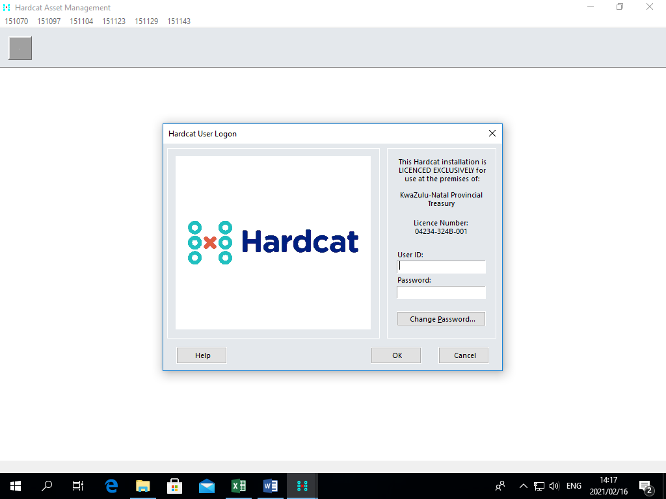

- Click in User ID and enter in your allocated User ID Code.
- Click in Password and enter in your allocated Password Code.
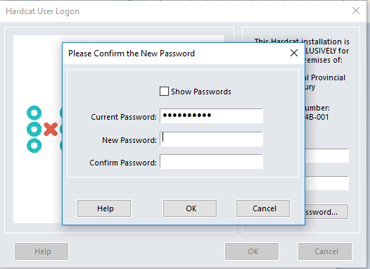
- Click on Change Password to allocate your own password
- Type in your new password and confirm
- Press Enter or click on ‘OK’ to confirm.
- You should now have access to the HardCat Main Menu.

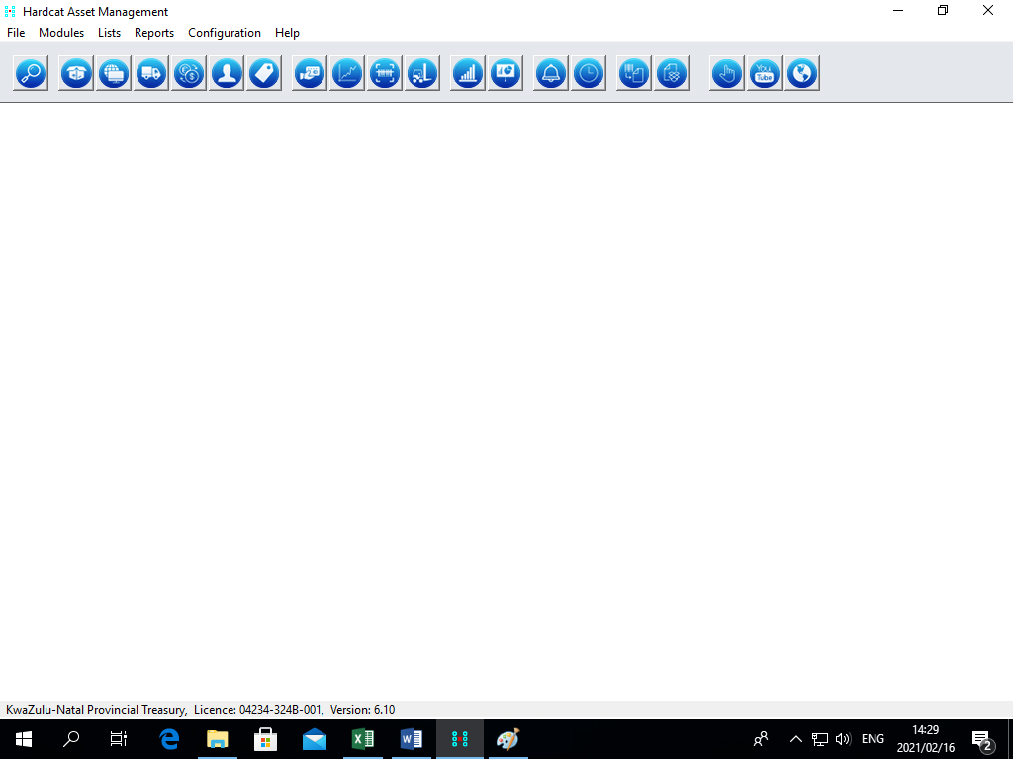

Please contact your internal HardCat System Administrator if you receive a message that your User ID or Password is invalid.

11. HardCat User Administration
Only a HardCat Syscon & Assistant Syscon can maintain HardCat Users. The Syscon has an Administration User Profile can create users, restrict access to certain areas of HardCat, and deactivate users if necessary.

12. HardCat Security
HardCat has been designed to give additional levels of security over your asset management database on top of the standard Network security. HardCat Users with Administration privileges, known as Administration Users control this.

Occasionally users may not be logged out of the database properly, potentially preventing the user from logging back into the HardCat system. This can occur when a user's machine crashes (i.e. due to a power failure) since the user does not get a chance to log off. The Admin User Log-in is used to reset these Users. This is the only login that can reset Users.
13. Why can't I log in?
It may be that the last time you logged in to HardCat, you did not exit properly or your machine crashed. The database may still register you as being logged in therefore; you will not be able to log in until you reset yourself. The admin user login is used to reset users and is the only login that can do so. Once you log in as the admin user with User ID as ‘ADMIN’ and the password ‘USER’, this takes you directly to the security options where you can highlight your user login and click on reset.

14. HardCat Core Module Functionality
An essential function of Asset Management is the ability to effectively and accurately control and monitor the movement of assets. This function is often a problem within organizations; however, through the use of HardCat this can be overcome.

In the HardCat Core Module the unique identifier is the Asset Code. Each asset has an Asset Code (Number) and is recorded on the system by this identifier. Additional Identifiers are Serial Numbers and Asset Labels with Barcodes. Barcodes and Serial Numbers have the same search functionality as the Asset Code; therefore there is more than one way to identify an asset in the HardCat database. Assets can be attached to a user defined physical location; locations can be a room, floor or building. The more detailed the physical location structure, the easier and more accurate an asset audit is to perform. Assets can be attached to Cost Centres to encourage ownership of assets. This enables asset listings to be produced for managers to accurately reflect the assets they are responsible for. Personnel within your organization can be loaded into the HardCat system, creating individual accountability for assets.

15. Type Structures
HardCat allows users to categorize Asset, Location, Cost Centre, Supplier and People types into definable structures to better organize data and allow powerful information retrieval and reporting.

Purchase Orders
Cost Centres
Stock
Charts
Statistical charts
Contents
Online Videos
Locations
Suppliers
people
Products
Notifications
Depreciation sets
Barcoding
Issue Stock
search results

assets
Alert
HardCat on the Web
Move Assets

People

Assigning assets to people within the HardCat database means that the responsibility of an asset is attributed to that person. This is specifically designed to track attractive and
portable items including laptops and mobile phones. People can be configured in a hierarchical structure in exactly the same way as locations and Cost Centres.

Having people recorded on HardCat also means Help Desk problems can be assigned directly to a Person within your organization rather than to a department and that their default contact details will be included in the problem/fault. In addition, the caller with the problem can be monitored to analyze whether their equipment use is creating problems.
People are also utilized within the purchasing module to set purchase order limits and to track requests and authorizations.
Including a Person Structure in the HardCat database also means that Maintenance Work Orders can be created for specific individuals and responsibility assigned to that individual.
The person structure is also imperative for HardCat Users, as it details a complete history of an assets and who made any adjustments or updated records.
It is recommended that an Employee list from HR, a phone list, or a Login ID list are used to create the people records. This list, if in a spreadsheet format, can be simply imported using the Import/Export feature of HardCat and assists with refreshing information on a periodical basis.

People Types
Determine the User Defined Preset Questions/fields that appear on each Person record. System generated presets are applicable for People Types; these presets are Phone, Fax and Email address. This data is used for Maintenance and Help Desk Modules. If you are not using Maintenance or Help Desk then you may have only one Person type, or possibly not even use this field.

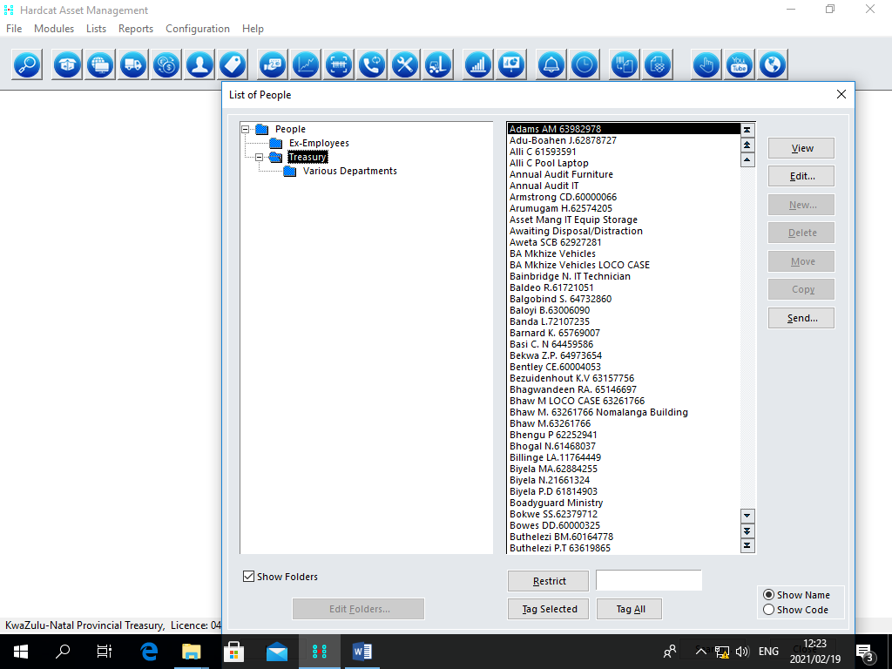

Products

Predefined Products are created to reduce the data entry time in HardCat. All HardCat modules, with the exception of Depreciation, utilise this Product Catalogue. Creating a product in HardCat simplifies the ordering process of new assets and Stock Items in the Purchasing and Stock Modules. The Product is used in the Base and Barcoding modules to create the description of the asset. In the Help Desk and Maintenance modules, products are used to determine the parts required for Maintenance Tasks or Help Desk fault repairs.

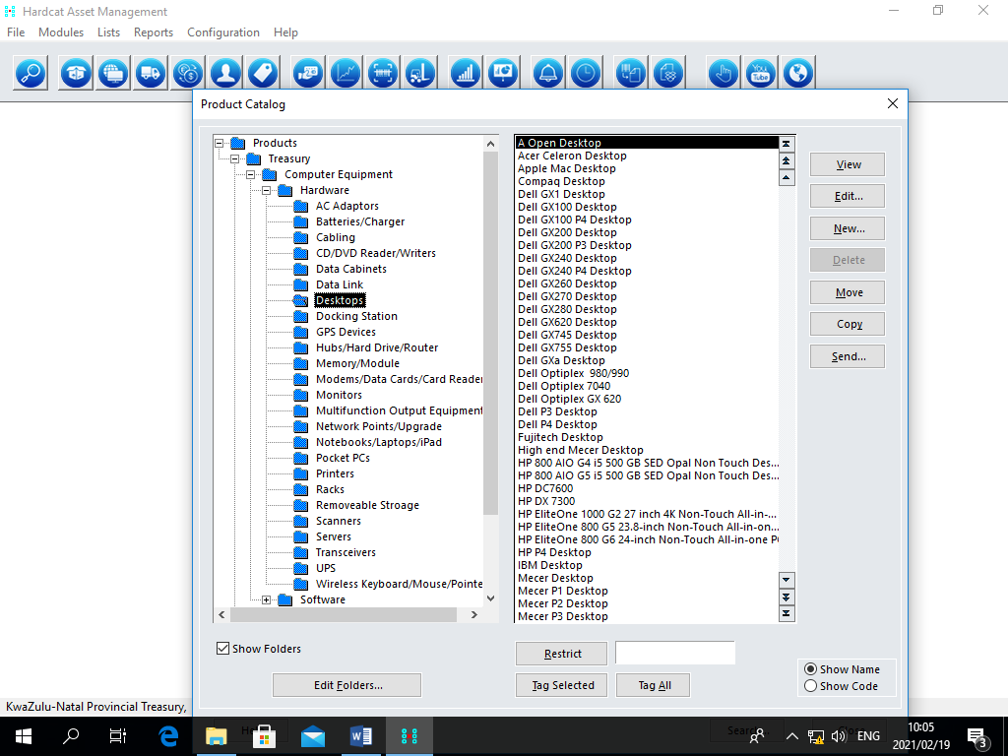

Asset Types

Like other entities in HardCat, assets are grouped into different classifications for information clarity and reporting purposes using the Asset Type Structure. In addition, Asset Types are used to determine default depreciation classes, maintenance classes and preset classes.

In HardCat, Asset Types can include Desktop PCs, Laptops and Chairs. The analogy for Products is that products are featured in a product catalogue and they do not exist in an organization unless they are purchased and these products become assets, or stock in the HardCat database.
HardCat uses Products to facilitate the creation of assets and the naming or the description of an asset.

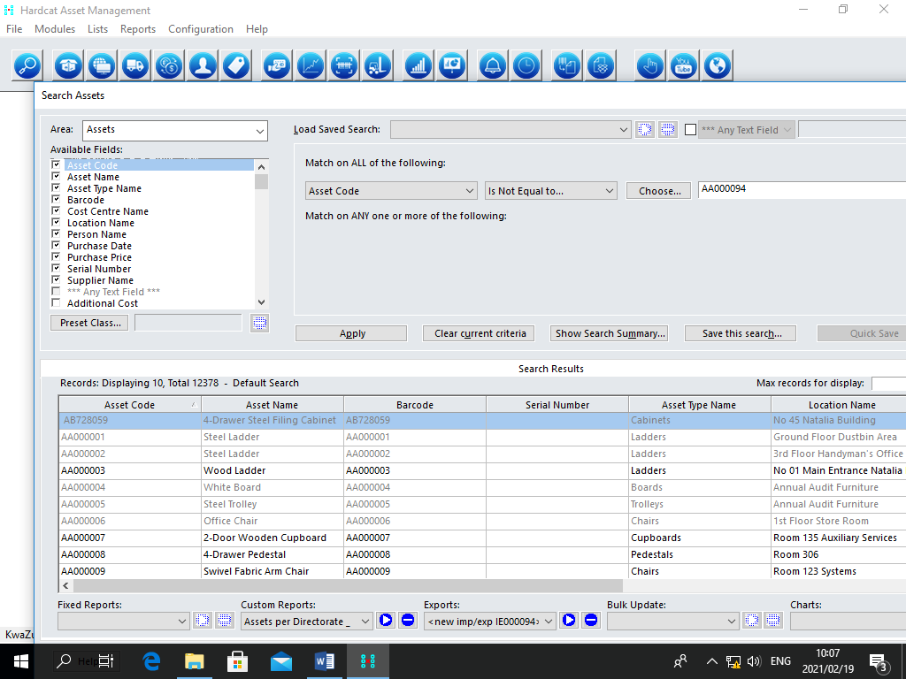

Cost Centres

A Cost Centre structure represents the management or ownership structure of your organization and should be related to your General Ledger. By listing all the Cost Centres within your organization and attaching the assets to one of these Cost Centres, ownership and accountability of assets can be assigned. As with locations, a hierarchical structure based on folders should be used to split Cost Centres into more manageable groups and allow for ease of reporting.

Cost Centre Types
Determine the user Defined Preset Questions/fields that appear on each Cost Centre record. Cost Centres have System generated presets, which are used to create General Ledger records in the Depreciation Journal. If you are not using HardCat to calculate depreciation values for assets then you may have only one Cost Centre type, or possibly not even use this field.

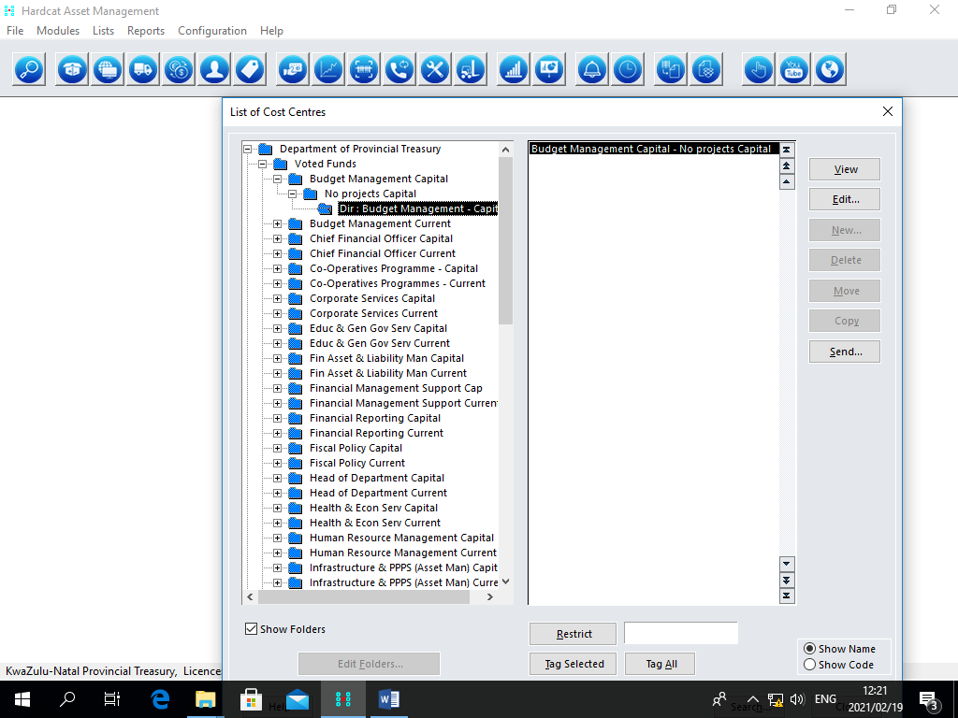

Locations

Locations represent the physical areas of your organization. A hierarchical structure based on folders should be used to split locations into more manageable groups and allow
for ease of reporting. A building may be grouped into different floors, with the rooms/areas or workstation numbers being the actual locations. This will allow assets contained on a floor or within a building to be reported on easily,. By attaching assets to one of these locations the recording of asset movement is possible.

Location Types
Determine the User Defined Preset Questions/fields that appear on each location record. If you are using HardCat to create Purchasing information for Assets or Stock, you may have specific delivery locations that require further information (other than Location Description). If you are not using Purchasing, you may have only one location type, or possibly not even use this field.

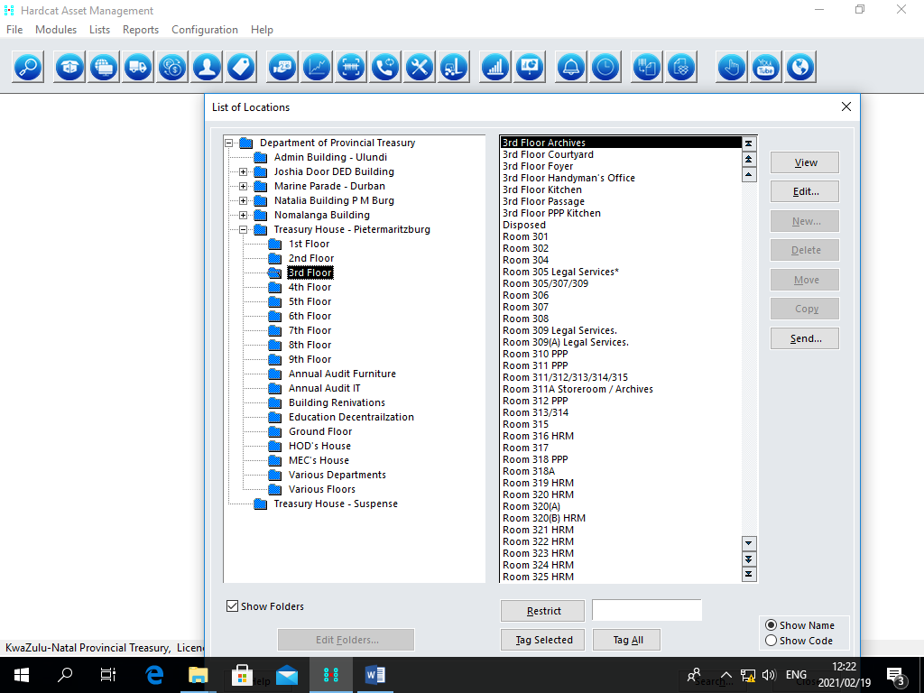

Suppliers

The Supplier structure is a vendor listing of your organization's asset Suppliers. This structure should be derived directly from your Accounts Payable Ledger. Once again, this information can be imported through a spreadsheet using the Import/Export feature of HardCat. Most organizations use a flat structure for Suppliers for ease of data refreshing.
Identifying the type of assets and recording the maintenance on these assets provides a quality assurance check on the Supplier's products. It also ensures the terms of the Supplier's Service Level agreement are met.

Supplier Types
Determine the User Defined Preset Questions/fields that appear on each Supplier record. Supplier Types are essential if you are using the Purchasing Module of HardCat and can be valuable for Warranty information on Assets and the Help Desk Module. If you are not using Purchasing or Help Desk Modules or recording warranty information then you may have only one Supplier Type, or possibly not even use this field.

EG: Additional information required for suppliers could include: Address Line 1, Address Line 2, Suburb, State, Postcode, Phone, Fax, Email, Contact Name and Contact Title. Different Supplier Types may be required for International Suppliers so that the Country can be recorded.

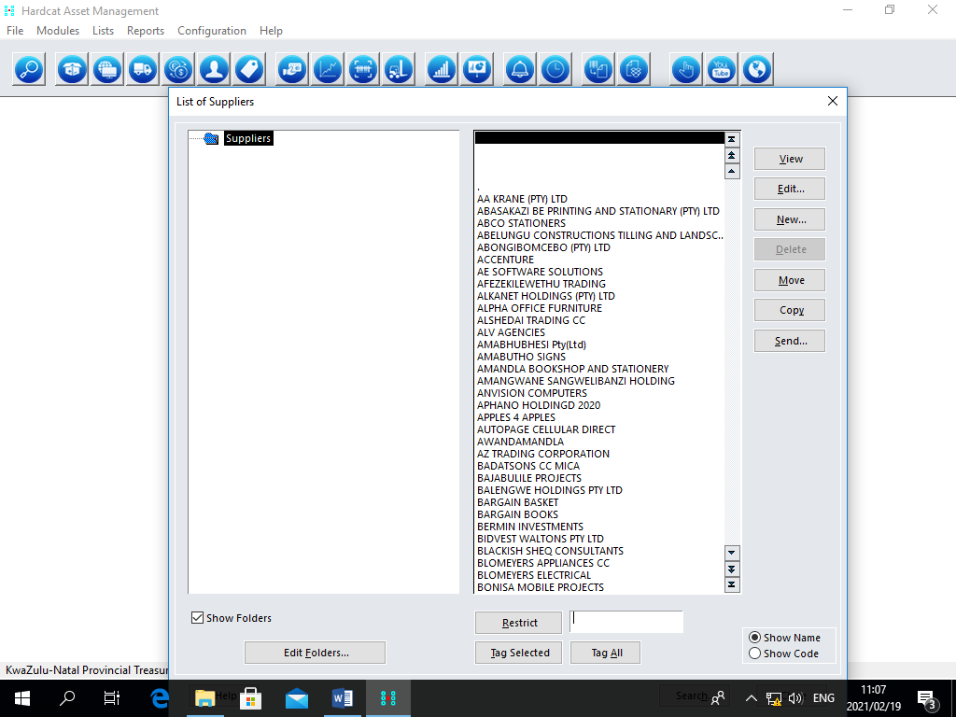

HardCat as the core system has the following modules (diagram below)
BARCODING MODULE
MAINTENANCE MODULE

PURCHASING MODULE
HELP DESK MODULE
HARDCAT CORE SYSTEM

STOCK MODULE
DEPRECIATION MODULE

- Purchasing
  - The Purchasing Module offers system users comprehensive Management control of all order processing of assets, from Budgeting, purchase order, delivery, invoicing and final disposal.
  - The very key element of an Asset management system is the ability to issue purchase orders for assets and stocks, to receive the goods and capture the details in order to be able to provide relevant financial data.
  - The Purchasing Module enables an organization to effectively:
- Order
- Monitor
- Deliver

It also allows the creation of an asset in the HardCat Core Module.

  - The Purchasing Process order has three major stages on HardCat:
- Create the Purchase Order using the Product List.
- Deliver the items on the Purchase Order,
- Invoice the items on the Purchase Order,

- Bar-coding

  - Asset information is recorded via a hand-held barcode reader which has a pre-programmed interrogation system enabling the system user to collate data efficiently, accurately and in an organized and efficient format

- Maintenance

  - Designed to meet the needs of managers responsible for Equipment maintenance and safety testing, it controls and administers both the scheduling of asset workplace Maintenance and preventative maintenance.

- Depreciation

  - The Depreciation Module is a fully featured system offering functionality for depreciation (including straight-line, reducing balance, and immediate write-off methods) as well as revaluations for WDV or book purposes. The module can be configured to integrate with a wide variety of accounting packages and offers enough flexibility to meet virtually any accounting, tax or insurance reporting requirements.
Depreciation classes are used to define depreciation rates, methods and general ledger information.
There are three levels (of asset type) that will appear in the financial statements, the third level is where depreciation will be calculated

. Stock and help desk are not yet available.

16. Reporting for Managers

HardCat is a flexible system that includes graphics, provides output that can be used in Microsoft office and which permits the use of third party reporting products.
HardCat generates a number of system reports that make up the system's audit trail. They can be useful in tracking changes made to assets within your system as well as who performed them and when.

HardCat Log
This report shows all actions that a User has made against an Asset in HardCat.
It reports on actions performed against each asset listing the following information going across the page.
Area | This is the area (or module) of HardCat where the operation was performed. Note that the Assets area refers to the Core Module.
Type | The type of operation performed on the asset. Eg. Edit
Entity Code | The asset code of the asset being modified.
Changed Entity | The entity that is being modified. Eg. Location.
From | The value prior to the operation being performed. Eg. SYDNEY
To | The new value Eg. MELB.
User | The User ID of the Person who performed the operation. Eg. SUPER.
Date | The date the operation was performed. Eg. 2001/01/01.
Time | The date the operation was performed. Eg. 10:03:13.

HardCat System Log
This report details information about actions performed on assets that involve HardCat system processing; examples of which are importing, a depreciation calculation, and the generation of Work Orders. This report lists the following information.

Area | This is the area (or module) of HardCat where the operation was performed. Note that the Assets area refers to the Core Module.
User ID | The User ID of the Person who performed the operation. Eg. SUPER.
Person Name | The name of the Person assigned to the USER ID.
Description | This describes the operation performed. Eg. Depreciation Calculation.
Date | The date the operation was performed. Eg. 2001/01/01.
Time | The time the operation was performed. Eg. 10:03:13.

HardCat Users Report
This report details all users within your HardCat system and their respective Access Levels within HardCat.

User ID | The User ID of the HardCat user
Description | The description of the User including the Person Name, whether or not the User is active and where the user starts within the database
Access Levels | This details the User Access levels to the different sections within HardCat

As with other areas of HardCat you are able to choose the Scope of the Report, by choosing either All of HardCat or Results of Last Search.

Reporting on HardCat can be further illustrated with the diagram below

Custom Report
Assign fields required

Search Based On

All of HardCat
Search Results

Report Output
Based on scope of search criteria

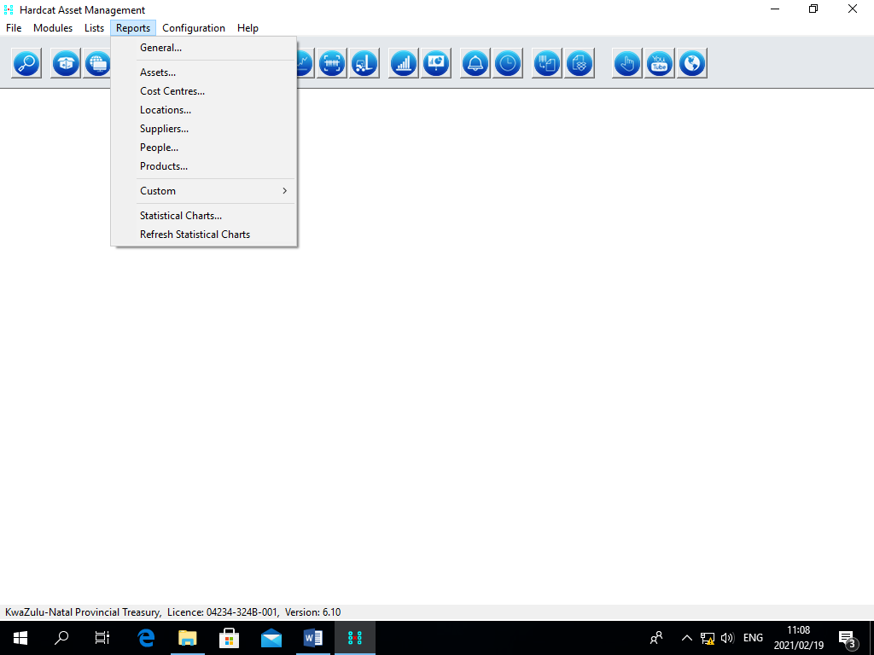

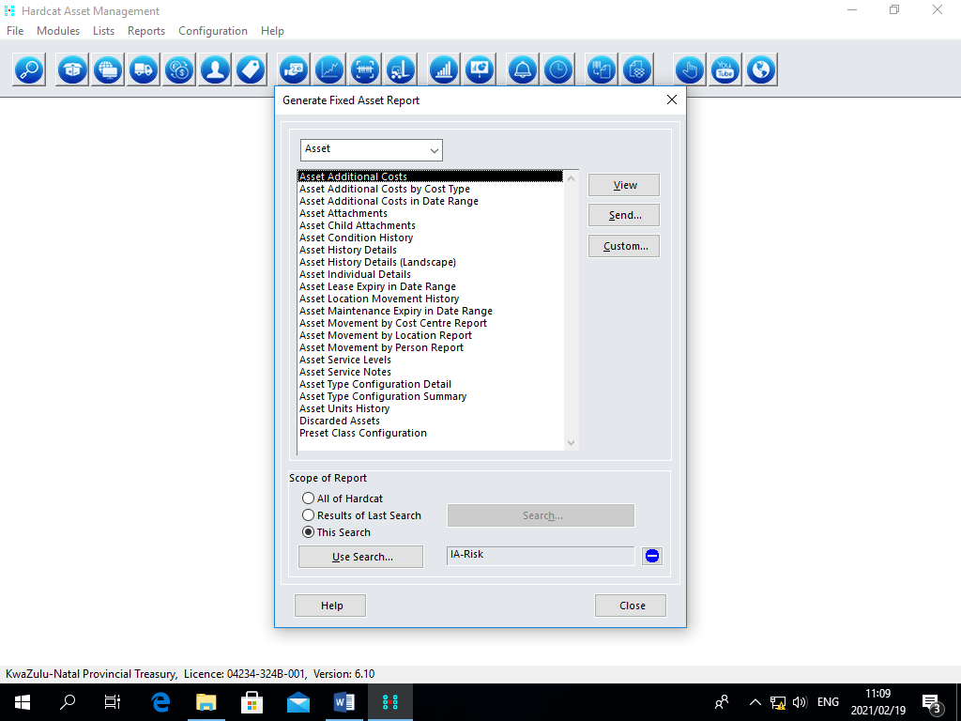

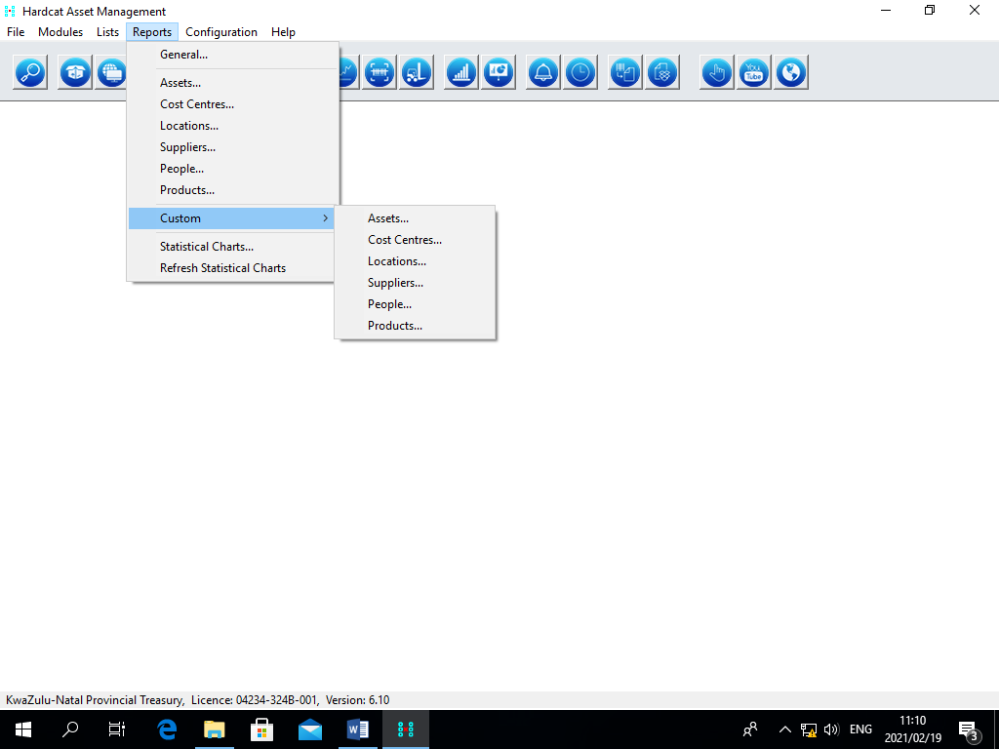
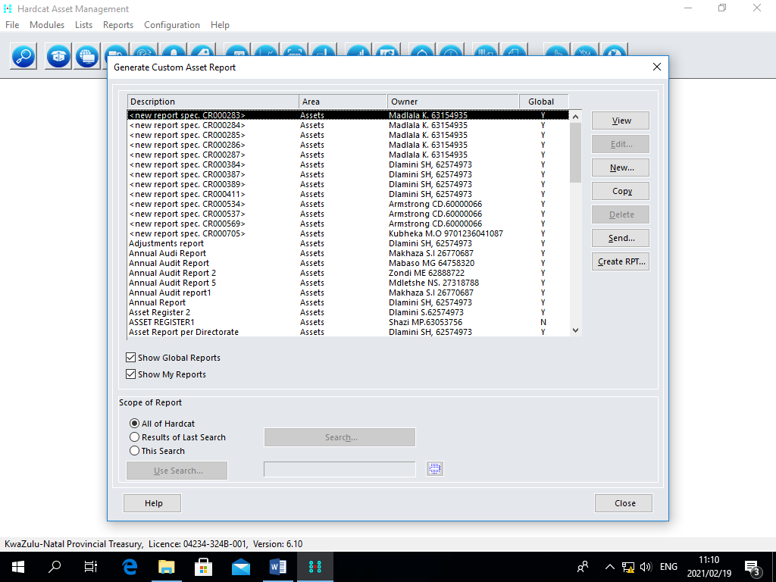

17. Budgeting

Financial data is fundamental to effective management and planning and as such is a cornerstone of HardCat, therefore HardCat facilitate budget capturing.

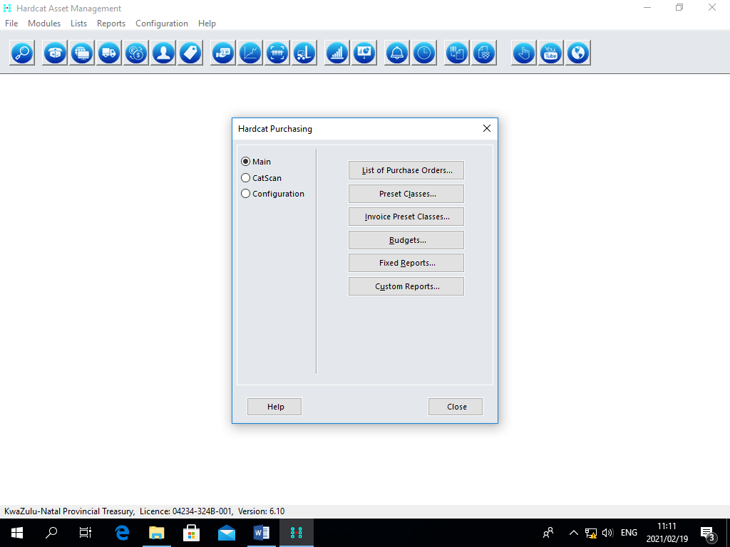

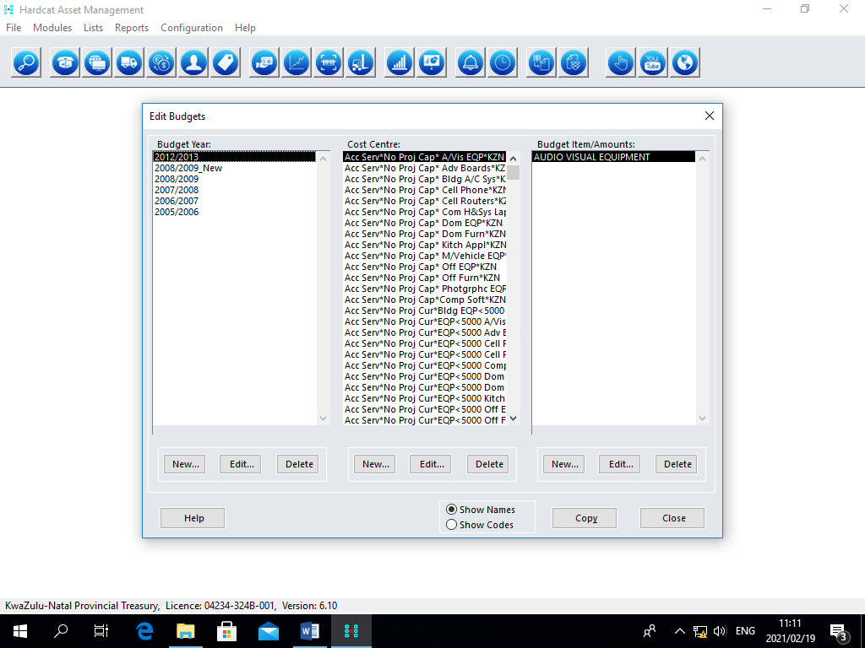

18. Stores

The management of assets should also cover those assets consumend in the course of business together with those that are too small to be individually identified. HardCat’s stock Control provides for the management of these.

19. Benefits of using HardCat
- Produce accurate financial reports
- Maintain consistent data
- Improve security/reduce insurance risk
- Eliminate unnecessary expenditure
- Manage obsolescence
- Save time and money.

20. DEFINITIONS
Asset Register: It consists of information on Acquisition, Usage, and Maintenance.

With regard to Asset Records the following is required:
- Asset type – product
- Supplier
- Person
- Cost centre
- Location

Parent Child Relationship: The relationship between 2-pieces of equipment e.g.
Computer & Keyboard. The attachments are considered as “child”

Presets: Added information that may be recorded for a specific entity e.g. Asset type.

Hierarchies: Information is stored in various attached levels e.g. Location : Treasury House – 4th
Floor – west wing – room 202.

Product Naming Conversion : State the Make / Model / Asset Type eg Mazda / 2005 /
Motor Vehicle. NOTE: EVERY PRODUCT MUST BE LINKED TO AN ASSET TYPE.

Search Facility: It provides the user with the ability to search for information by criteria.

Custom Report : A report is generated according to fields (criteria) selected. Such reports do not
Include SOLD ASSETS. Refer to the sketch on page 3.

Barcoding - the process of capturing & uploading barcodes into pocket P.C’s

Depreciation – the process of writing-off an asset over its useful life. This function to be managed by Treasury.

Help Desk – facility to assist with problems & offer support

Maintenance – the process of tracking maintenance schedules & records

Purchasing – the process of acquiring asset – within stipulated budgets

Stock – the process of recording consumable stock purchase & usage..

Entities: (Information specific to a particular asset)

Asset Type -grouping of assets into particular categories e.g. desks, chairs, tables (products) may be grouped as Office Furniture (asset type)

Product – the actual / tangible product e.g. desk

Location – the exact location / point where the asset is located

Cost Centre – the department that paid for the particular product

Supplier – approved suppliers as per government data base.

People – specific person to whom assets would be assigned according to
usage e.g. Desktop P.C

